
HINDU UNIVERSITY OF AMERICA
BHAGAVAD GITA CERTIFICATE PROGRAM(BGCP)
ENROLLMENT AGREEMENT

© HUA – [2022]

Pine Lake Retreat Center,
21725 FL-33,
Groveland,
FL 34736
U.S.A

support@hua.edu +1 407-205-2118 +1 407-545-5057

RECITALS

This Enrollment Agreement (this "Agreement") is made effective between Hindu University of America Inc of Florida, (the "University"), located at Pine Lake Retreat Center, 21725 FL-33, Groveland, FL 34736, and the student named below (the "Student"), for the duration of the program, as stipulated below.
Whereas the University is an approved religious educational institution registered with the State of Florida’s Department of Education, and compliant with Florida’s Commission for Independent Education Statutes pursuant to religious institutions, Section 1005.06(1)(f), offering programs of study in Hinduism.
Whereas the Student named below desires to pursue a program of study with the University on these terms and conditions, as set forth in this enrolment agreement, and the University has deemed that the Student to be eligible for admission into this program of study for the duration of this agreement.
Whereas the University is not yet accredited, and is actively pursuing accreditation, and the Student is fully aware of its current Non-Accredited Status, at the current time.
Whereas the University and the Student are hereby collectively called the “Parties”.
The Student certifies, under penalty of law, based on information and belief formed after reasonable inquiry, that the statements and information contained in these documents are true, accurate and complete.
STUDENT INFORMATION
Name: []
Address: []
Phone: []
Date of Birth: []
Gender: []
Email ID: [hua id]

PROGRAM INFORMATION

Name of the Program: Bhagavad Gita Certificate Program (BGCP)
Total required credits to complete the program: 6
Starting Quarter: []
Latest Completion Quarter: [2 year from starting Quarter]
The Student agrees to complete the Program within the latest completion/quarter as mentioned above.

PROGRAM COMPLETION REQUIREMENTS:
The Student agrees to comply with the completion requirements of the Program as stated below within the stipulated time frame. This includes:

- Completing all coursework as prescribed in the program.
- Earning required credits with a cumulative GPA of 2.0 or more.

TUITIONS AND FEES
The Student agrees to pay tuition and fees to the University as set out in the HUA Program Fee Addendum shared with the student. Adjustments to the fee will be made for any credits already earned. The final fee structure for the student will be available in the HUA Program Fee Addendum.
Any changes or modifications should be approved in writing by the HUA Administrative Staff, and an updated Program Fee Addendum will be shared with the Student.

STUDENT LOANS
HUA does not offer student loan programs to its students currently. However, partial scholarships are available for students. For details, please write to info@hua.edu

CANCELLATION
The Student has the right to cancel this Enrollment Agreement and obtain a full or partial refund of fees paid by the Student to the University, as set out below and by completing and submitting the relevant cancellation form in the University’s learning management system.

REFUND POLICY
If the Student cancels this Enrollment Agreement, the University will refund any money that the Student paid except the non-refundable administrative fees, as set out below. Any books issued and received by the Student would not be returnable.
PROGRAM REFUND POLICY

Time Cancellation Occurs | University will Retain | Student will be Refunded
Prior to or during the first Quarter of the Program | As per course refund policy | First Quarter fee will be retained as per course refund policy. Remaining program fee will be refunded.
After the first Quarter of the Program | The completed Quarters fee  For the in-progress Quarter, fee will be retained as per the course refund policy.  For the remaining Quarters  20% of the remaining paid fees will be retained. | For the completed Quarters no fees will be refunded.  For the in-progress Quarter, fee will be refunded as per the course refund policy.  For the remaining Quarters 80% of the remaining paid fees will be refunded.

COURSE REFUND POLICY

Time Cancellation Occurs | University will Retain | Student will be Refunded
Prior to or during the first week of the course | 0% | 100%
During the second week of the course or later | 25% | 75%
During the third week of the course and at any time later until the Student completes 50% of the course | 50% | 50%  Students may transfer to other alternate courses, with the permission of the Director of Registrations.
After the Student completes 50% of the course | 100% | 0%

CONFIDENTIALITY POLICY
As the University offers courses online, the lectures are prepared and delivered by individual faculty members from various locations via live, interactive Zoom or other electronic and online sessions. The study materials and class recordings are made available to the students if and as long as they remain a Student of the University. In the case of the Student not enrolling for courses for a continuous period of 4 quarters or 2 semesters, their login credentials will be terminated until the applicable reinstatement fee is paid to the University.

The material shared with students enrolled in online courses, including but not limited to lectures, recordings, PowerPoint presentations, notes, readings, and feedback on discussion boards, always remains the property of the University. These materials may not be shared with those not enrolled in the class, nor may these materials be uploaded to the internet, a listserv, or shared or distributed via other means of dissemination. The ideas and insights shared during classroom sessions are made available to enrolled, fee-paying or scholarship students only. The Student may not share course materials in any shape or form with non-enrolled students. No Student may record the online course, either through the LMS module or Zoom or by any other means. By registering into the University’s courses, the Student agrees not to discuss, use, forward, print, copy, photograph, record, upload or otherwise disseminate any confidential or sensitive information or study materials.

CREDIT TRANSFER

The rules and the procedures for transfer of credits, from the University to any other educational institution are determined by the receiving institution. Although the University will be cooperating with other institutions for streamlining such procedures, at the present stage, there is no implied or explicit guarantee that such a transfer will be possible. Even though there is precedence where other institutions have accepted credits for courses taken at the University, the Student is advised to inquire about such acceptance from the applicable or relevant institution(s) before finalizing study plans and registering for any Program at the University.

Credit transfer to the University for credit hours earned at other institutions will be approved at the sole discretion of the University’s Academic or other relevant Committee.

PLACEMENT

The University does not guarantee job placement for the Student upon completion of this Certificate Program. But the University anticipates that Students will greatly enhance their effectiveness in their lives, careers, professions, relationships, and sense of contribution and service.

PROMOTION

The Student also agrees that the University can use the Student’s feedback and / or testimonials that they may have shared with HUA as a student or an alumnus, for general promotion and marketing purposes, on the website, brochures, and social media, with the Student’s consent. The Parties agree to share the Student’s feedback or testimonial for promotion and marketing purposes, only with their mutual consent and alignment.

DISPUTE RESOLUTION

The Student and the University together agree to resolve all disputes arising from this Enrollment Agreement at the University, no matter how pleaded or styled, through a process of mutual discussion. The Student agrees to initiate such a discussion by writing a detailed email stating the nature of the dispute to support@hua.edu.

If after all attempts to resolve the dispute have been made and it remains unresolved, it shall be resolved by binding arbitration under the Federal Arbitration Act conducted by the American Arbitration Association (AAA), at Orlando, Florida under its commercial rules. The award rendered by the arbitrator may be entered in any court having jurisdiction. Any holder of this Consumer Credit Contract is subject to all claims and defence which the debtor could assert against the seller of goods or services obtained pursuant hereto or with the proceeds hereof. Recovery thereunder by the debtor shall not exceed amounts paid by the debtor thereunder.

If there are concerns that have not been sufficiently addressed, please follow the instructions provided here: https://www.fldoe.org/sara/complaint-process.stml

The Student agrees that the Student’s signature below certifies that the Student has read, understood and agrees to the Student’s rights and responsibilities, and that the University’s cancellation and refund policies have been clearly explained to the Student and has been understood.

This Enrollment Agreement is accepted by:

Type Full Name to Sign ____________________________________
(Signature should exactly match the name below)

Student Name _____[Student Name]_____
Date __[Current Date]_____


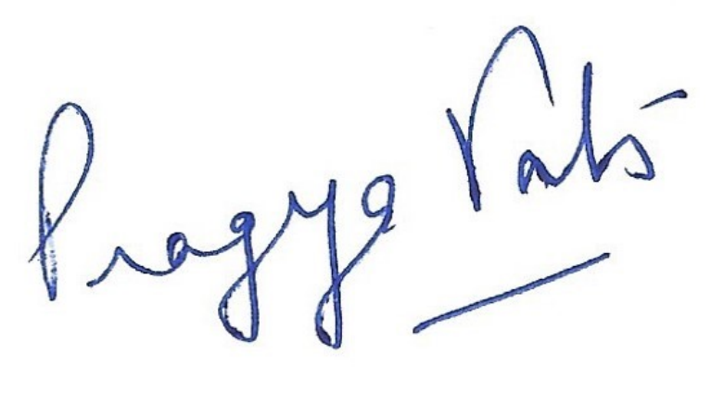
________Pragya Vats___________________
Director of Admissions & Registrations

